THE RETURN OF JOURNALISM
With the start of a new school year comes new students, teachers, and most importantly classes. This year Tustin High School added a Journalism class to a students’ choice of electives. This year’s Journalism class is run by Mrs. Kim Robinson, current English and Film Analysis teacher and author of the book For Underdogs Only. With the assistance of Mr. Eric Zamora and Mr. Roland Jones, Tustin High is to rekindle their love for Journalism and publish an online magazine.
2008 marks the last year Journalism was present at Tustin High, and the last year Mr. Brian Caulfield, a current English teacher at Tustin, conducted the class. In a recent interview I held with Mr. Caulfield, I asked him about his time teaching Tustin High’s Journalism class and the productivity of his students. He spoke of Tustin being the only school for a while without the privilege of having a Journalism class, and told me how content he is with its return. When I asked if any previous students of his went on to pursue a career in Journalism, he responded with an overwhelming number of names. Mr. Caulfield spoke very highly of his Editor in Chief, Sarah Mosqueda. He told me about the time she was recognized by the Los Angeles Times for her work on an article regarding the U.S. military. The article detailed how the military services came onto the Tustin High school campus to retrieve students entering the Army. The students were pulled from class during final exams and taken to receive physical exams from Army doctors. Sarah received her award at the Los Angeles Times penthouse suite. She went on to receive a full scholarship to UC Berkeley. Along with Sarah, several other students in Mr. Caulfield’s Journalism class received full scholarships to various colleges across the nation.
With the return of Journalism, I asked Mr. Caulfield if we could expect to see a collaboration between him and Mrs. Robinson. Without skipping a beat, he said, “I am glad I did [Journalism] while I was younger because I had a lot more energy then…I am glad that Mrs. Robinson has a lot of energy.”

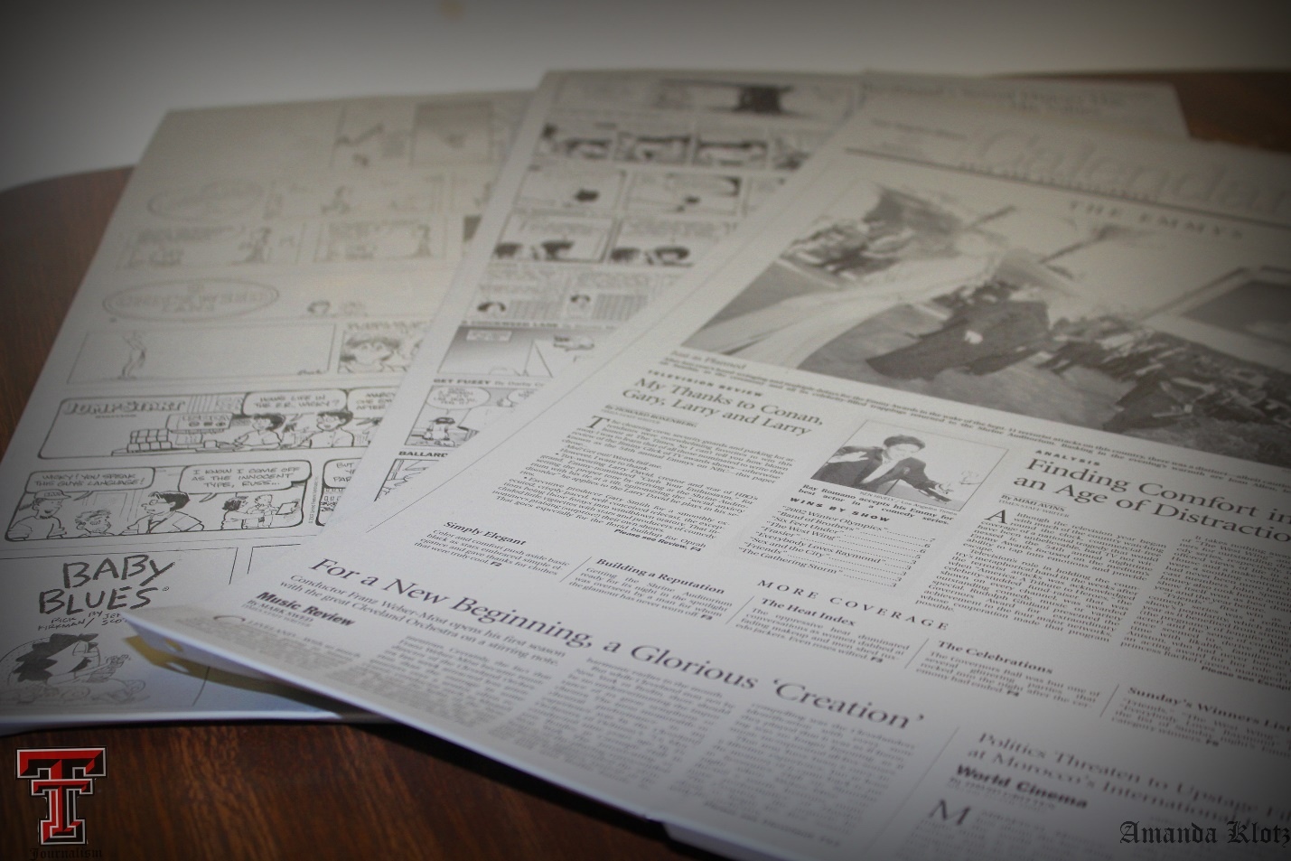

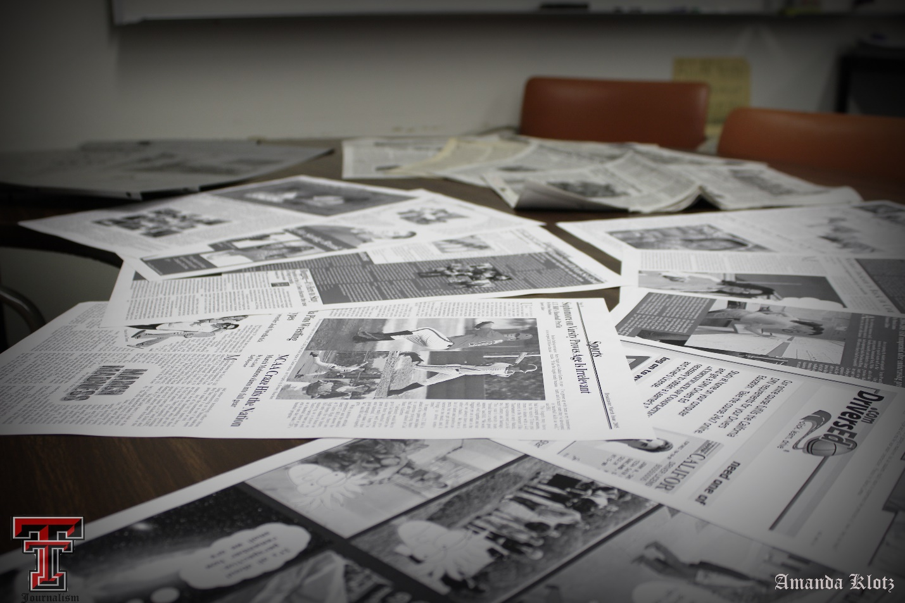

Embedded Links For Highlighted Words:
http://www.forunderdogsonly.com/
http://www.tustin.k12.ca.us/tustinhs
http://www.latimes.com/
http://berkeley.edu/index.html

